* ASSIGNMENT-01
* Create an account on AWS and launch the instance
  + Create an Amazon Web Services root or IAM user account.
  + Open ec2 services, then instances, and finally the Mumbai, Asia region.
  + Give your instance a name, then select it by clicking on the window OS.
  + Select the kind of instance (t3.micro).
  + Now, create a name for your key pair (the format should be .pem or .ppk depending on your needs, and the key pair type should be RSA).
  + After you generate your key, it will be downloaded immediately.
  + If you want to send SSH traffic from anywhere on the internet, use 0.0.0.0/0 or my IP address.
  + Now press the "launch instance" button.
  + After your instances have been launched, navigate to them and select your instance.
  + Choose "connect," then "RDP client," and then "download."
  + Now, select Get Password followed by Upload Private Key.
  + Then choose and upload your pem or ppk file.
  + Then click the decrypt password button and copy your password.
  + Open your remote desktop file, paste your password, and then click the “Connect Now button”. Your virtual window will now be open and ready for usage.

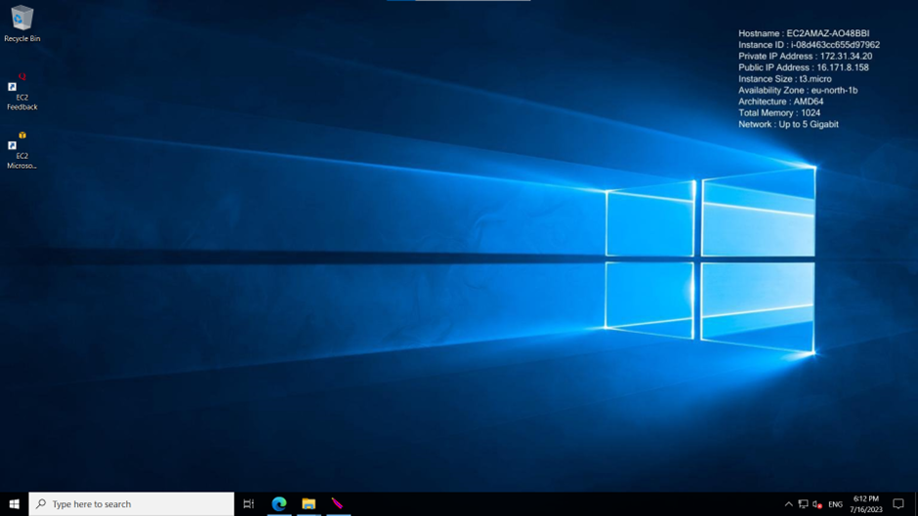

Installing Web server

* You must now run a web browser in to install Apache static web server to host static web pages on the internet.
* Simply search for Apache web server and choose your preferred file from the list of results.
* The file should then be extracted to the C disk using file explorer.
* After extracting the file, open it and copy the path to the bin folder. Start the administrator’s command prompt now.
* Now type cd, which stands for change directory.
* cd c:Apache24bin, then httpd -k install, and apache is now up and running.
* To test it, launch your web browser and enter 127.0.0.1 into the address box.
* If everything is in order, you should be able to see the "it works!" web page in your browser locally.

